**MQTT Mosquitto**

Guide to installing MQTT Broker on a Raspberry Pi.

Steps are listed below.

# Step 1: Installing Mosquitto

To Install the MQTT broker/server and the command line clients in case for debugging, we use these commands.

sudo apt-get install mosquitto

sudo apt-get install mosquitto-clients -y

we will turn-off those

# Step 2: Configuring the Mosquitto

To configure the MQTT broker Mosquitto, you need to know that there are two different configurations located here.

Default configuration:

/etc/mosquitto/mosquitto.conf

Extension to the default configuration:

/etc/mosquitto/conf.d

We need to edit the default configuration.

sudo nano /etc/mosquitto/mosquitto.conf

The broker should only include the default settings. We can do that by commenting conf.d inclusion.

We do not want anonymous users to connected to the MQTT broker: allow_anonymous false

We want to save the passwords in a separate file: password_file /etc/mosquitto/pwfile

The MQTT broker should be accessible on port 1883

The config will look like the following

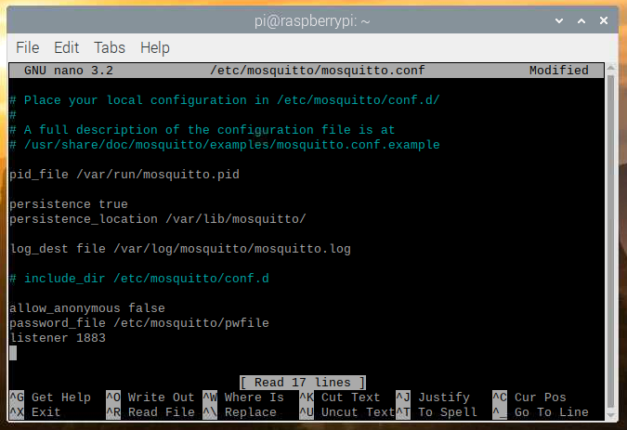

# Step 3: Create New User

To create a new user, we use these commands.

Username:

sudo mosquitto_passwd -c /etc/mosquitto/pwfile project

then we enter the password for the “project” user, which is “admin”.

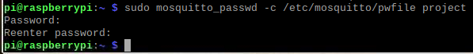

# Step 4: MQTT broker Status

To overview the current status of MQTT broker, we use this command.

sudo systemctl status mosquitto

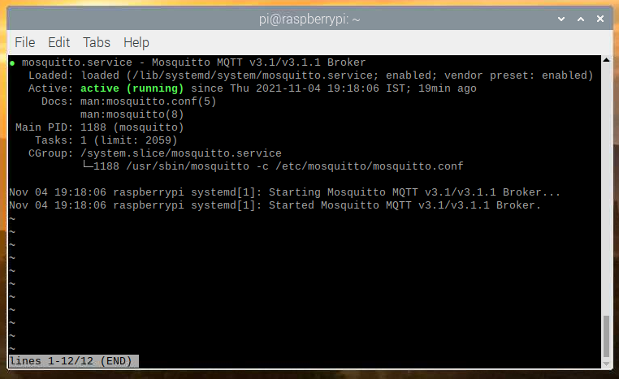

# Step 5: MQTT Python Subscriber

To run the python subscriber, we need to install the dependencies.

sudo pip install paho-mqtt

sudo pip3 install paho-mqtt

then to run the python program, we use this command.

sudo python3 mqtt_sub.py

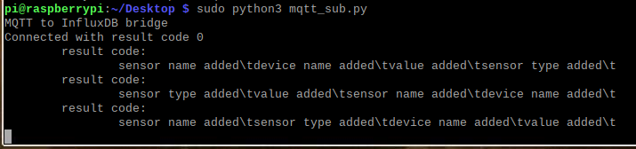

# Step 6: Deleting a User

To delete a user, we use these commands.

Remove existing user:

sudo mosquitto_passwd -d /etc/mosquitto/pwfile username